MT 178.3 ATTRITION RESISTANCE

SCOPE
The method is intended for measuring the resistance to attrition during normal transport, storage and handling of loosely packed granules or tablets. The method is applicable to granular formulations including ready baits and tablets which are packed in bulk and have a characteristic length of less than 1 cm (Note 1).

REASONS FOR THE REVISION
The objective of this revision was to combine MT 178 and MT 178.2 into a single method for granular products and to include loosely packed tablets. The procedure was simplified, editorial changes have been made and obsolete references have been removed. Where same conditions are used, results obtained with MT 178 and MT 178.2 are equivalent to those obtained with MT 178.3. MT 178.3 supersedes MT 178 and MT 178.2.

OUTLINE OF METHOD
Fine particles and dust from storage and transport of the sample are removed by sieving before the sample is attrited with or without glass beads depending on the type of formulation.
The test involves rolling a cylinder filled with granules/tablets, which results in a cascading wave-like motion. The relative speed between adjacent granules/tablets produces friction and causes surface attrition. In the presence of glass beads, friction and resulting surface attrition can be higher. Using glass beads allows to distinguish products with more attrition resistant surfaces.
Generated fine particles and dust are separated and the percentage larger than 125 µm is reported.

APPARATUS
Balance, with an accuracy of at least ± 0.01 g
Glass bottle, 500 ml with lid, outer diameter: about 8 cm, height: about 15 cm
Glass beads, bulk density 1.5 g/cm³, diameter 4.0 ± 0.2 mm
Glass rod, with a rubber cap
Pair of tweezers
Roller bank, system of two or more rollers forming a drive bed or equivalent systems, see Fig. 1.
Sieve, 125 µm, about 20 cm diameter
Sieve lid and receiver pan
One or two coarse sieves to separate tablets/granules from glass beads, for example 2500 µm or 5000 µm (Note 2)
Soft brush
Standard vibratory sieve shaker or air jet sieve (Note 3)
Stopwatch

PROCEDURE
In case of Granules (GR) or GR-like formulation types like certain Ready Baits (< 1 cm), the test is performed in the presence of glass beads to increase friction. The Granules must be at least 1/3 of the bead diameter or larger. Tablet formulation types (DT, ST, WT) are also tested in the presence of glass beads. For all other formulation types like EG, SG, WG, the test is performed without beads.

(a) Sample preparation
Sieve about 60 g (Note 4) of the sample for 3 min on a 125 µm sieve using a standard sieve shaker or air jet sieve (Note 3). This step is intended to gently remove fines from the sample. The fines are discarded and the dust-free sample is used for testing.

(b) Testing
Weigh about 50 g of the sieved sample to the nearest 0.01 g (m in [g]) and transfer it to a glass bottle (m [g]). For formulation types that require the addition of glass beads add about 50 g of these to the bottle. Close the bottle and place it horizontally on the roller bank (see Fig. 1).
Let the bottle carry out about 4500 revolutions at a rotational speed between 75 rpm and 125 rpm (Note 5).

(b1) Without beads
Weigh a 125 µm sieve to the nearest 0.01 g (mass of the sieve b [g]) and place it on the receiver pan. Carefully transfer all granules of the glass bottle onto the 125 µm sieve. Use brush and/or glass rod to remove granules adhering to the walls and the lid of the bottle onto the sieve. Cover the sieve with the lid and place it into the shaker. Shake for 3 min.

(b2) With beads
Transfer all material from the bottle onto an appropriate coarse sieve (Note 2) and carefully separate the granules/tablets from the beads (Note 6). Use brush and/or glass rod to remove granules/tablets adhering to the walls and the lid of the bottle.
(b2.1) If granules/tablets are larger than the glass beads, use a sieve with a sufficiently large mesh opening to separate the granules/tablets from glass beads and fragments. In a second step, use a smaller mesh sieve to separate the glass beads from the fragments. Continue with (b2.4).
(b2.2). If the glass beads are larger than the granules/tablets, use a sieve with a sufficiently large mesh opening for separating the glass beads from granules/tablets. Continue with (b2.4).
(b2.3) Where no physical separation of granules/tablets and glass beads by sieving is possible, the beads are removed using a pair of tweezers and no coarse sieve is needed. Continue with (b2.4).
(b2.4) Weigh a 125 µm sieve to the nearest 0.01 g (mass of the sieve b [g]) and place it on the receiver pan. Carefully transfer all granules/tablets and fragments onto the 125 µm sieve. Cover the sieve with the lid and place it into the shaker. Shake for 3 min.

(c) Determination of attrition
Tap the side of the 125 µm sieve five times, remove the 125 µm sieve from the pan. Weigh the sieve together with the overs to the nearest 0.01 g (mass of the sieve with sample after sieving c [g]).

CALCULATION

Attrition resistance [%]$\text{ = }\frac{a}{m}×\text{100}$

where:
a = overs on the 125 µm sieve: c - b [g]
b: mass of sieve
c: mass of the sieve with sample after sieving
m = mass of sample taken [g]

REPORTING
Report the attrition resistance to the nearest 0.1 %.
If tablets in the packaging are broken this has to be reported.

Note 1 The size limitation is needed to assure that granules/tablets can move freely.
Note 2 A coarse sieve is needed only for an attrition test with beads and has an appropriate mesh size for separating beads from granules/tablets. In case granules/tablets are larger than the beads, two coarse sieves would be necessary, one for retaining granules/tablets and one for the beads. Only in this case there would be no need for a 12 5µm sieve, and the initial dust removal screening could be carried out with the coarse sieve for granules/tablets.
Note 3 Hand sieving is also acceptable.
Note 4 In case of samples containing large amounts of dust, weigh more sample to ensure that - after removing the fine particles - at least 50 g of sieved sample is available for the attrition test.
Note 5 Measure the rotational speed of the bottle and adjust the time period for rolling accordingly:
adjusted time period [min] = 4500 rounds/N
where N is the measured rotational speed of the bottle [rpm]. N should be between 75 and 125 rpm.
Note 6: Dust can be ignored.

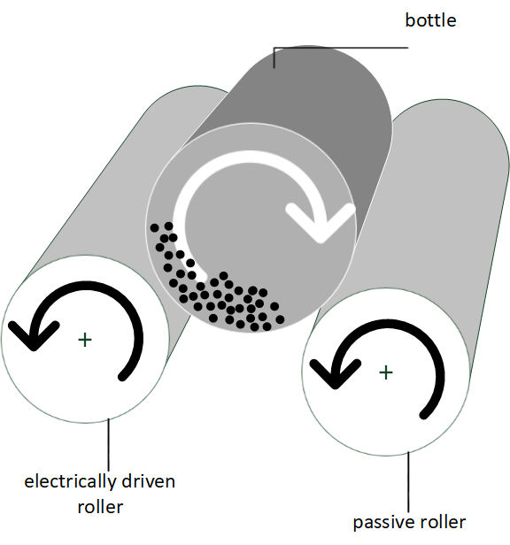
Fig. 1 Roller bank

